User story for car rental system:

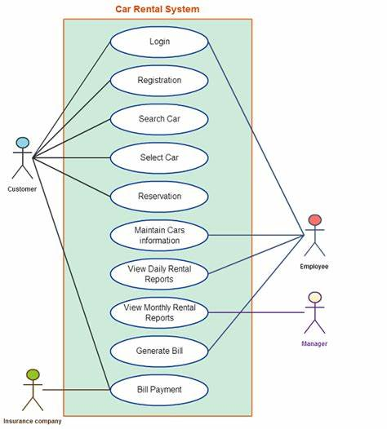

When user type is customer:

|  |  |  |
| --- | --- | --- |
| User type | Epic | User story |
| Customer | registration | As a first time when user see the website he need to register it.  Confirmation notification through email. |
| Customer | login | As a user, login through website or app by giving username and password.  If forget password and reset button is needed. |
| Customer | search | As a user, search functionality to find cars which are available.  Features of car like brand, color |
| Customer | Select car | As a user, I need to select car which is required. |
| Customer | Reservation | As a user, I need to reserve a car for two days.  Then payment details.  And bill generation for it. |

When user type is employee:

|  |  |  |
| --- | --- | --- |
| User | Epic | User story |
| Employee | login | As an employee, I need to login through employee id.  And authentication needed |
| Employee | Maintain cars information | As an employee, I need to maintain the available cars information.  If anything is damage, need to update it. |
| Employee | Daily rental reports | As an employee, I need to update daily about rental cars in a day. |
| Employee | Generate bills | As an employee, I need to generate bill for the car which is rented. |

When user type is a manager:

|  |  |  |
| --- | --- | --- |
| User type | epic | User story |
| Manager | Monthly reports | The first step is to login through credentials.  Check the works assigned to employees based on priority.  And view the monthly reports. |